**2. Create a virtual machine with two operating systems, Windows 7 (or Windows 10) and Ubuntu 20.04 (in this order) and configure the bootloader to:**

**b. Boot Ubuntu without displaying the menu after showing a 10 seconds countdown.**

The first thing we do is to change the seconds countdown from GRUB_TIMEOUT, and the GRUB_DEFAULT, we have to put 4 in order to Windows will be the default operanting system. Also we have to change the GRUB_TIMEOUT_STYLE, in order to apper the countdown 10 seconds.

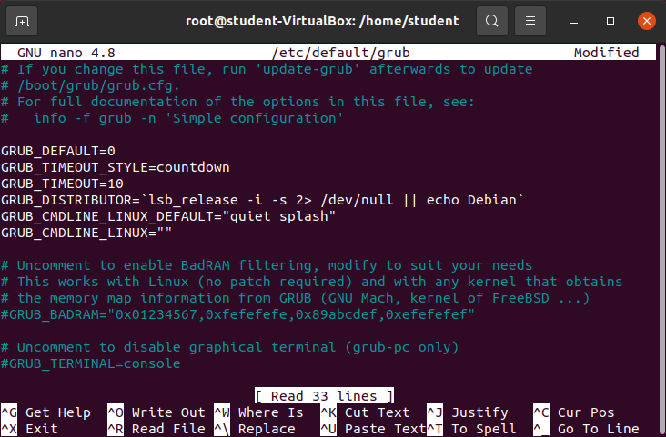

We have to press “*control + x”* to exit and after that save it.

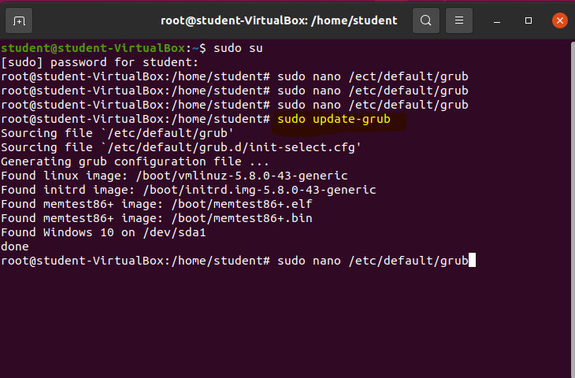To confirm this changes we have to use the command sudo update-grub:

Now we have to enter with the command ***sudo nano /boot/grub/grub.cfg*** and in the next screen we have to comment using the character ***“#”*** some of the last lines.

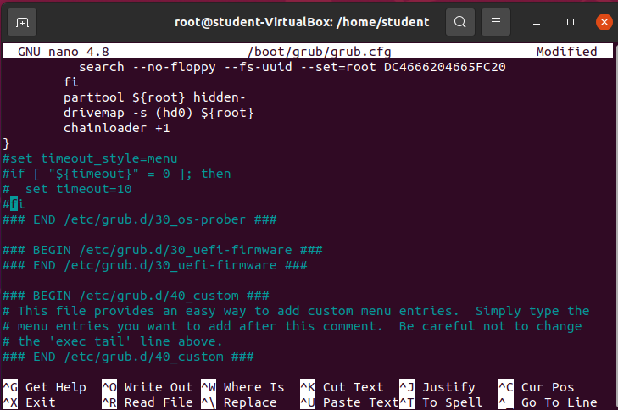

The next time we restart the screen will appear it is going to be like the screen below:

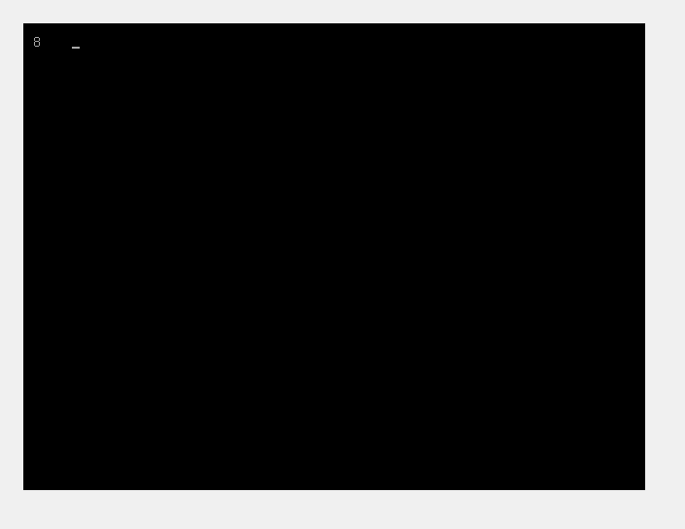

**c. Boot Ubuntu without displaying the menu.**

In order to do this we have to set GRUB_DEFAULT=0; GRUB_TIMEOUT_STYLE=hidden; GRUB_TIMEOUT=0

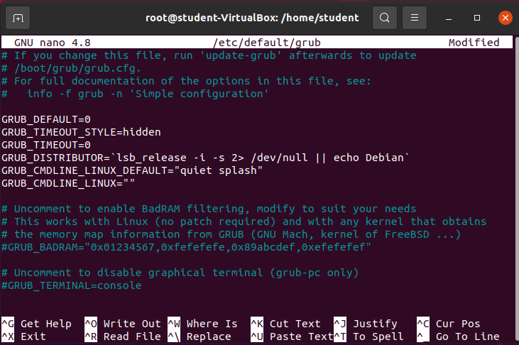

Confirm this with the command update-grub

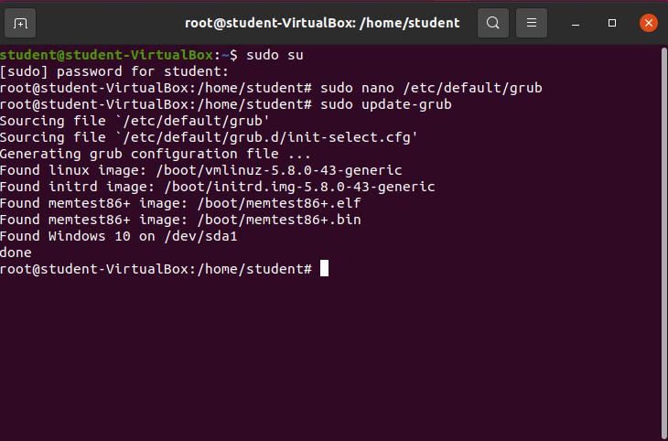

Put the command ***sudo nano /boot/grub/grub.cfg:***

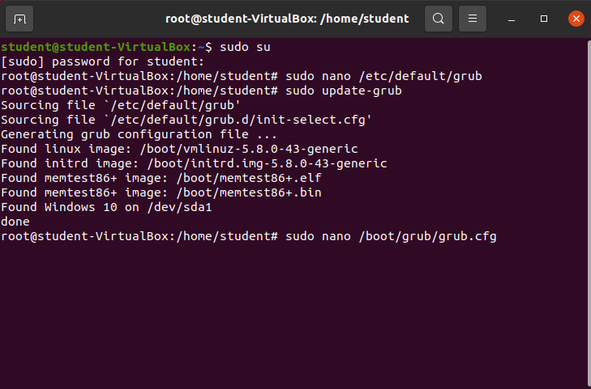

In the next screen we have to comment the last lines:

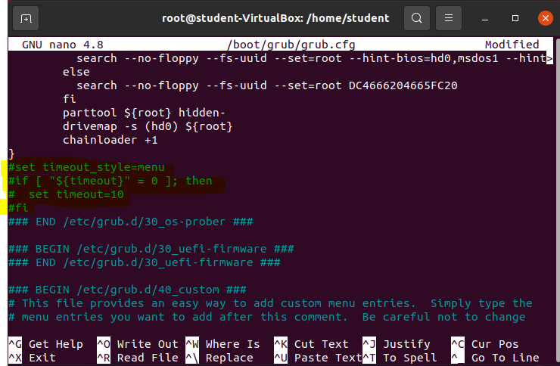

Then we have to confirm these changes with contro+x. and after that press y.

**d. Boot Windows without displaying the menu.**

In order to do this we have to set GRUB_DEFAULT=4; GRUB_TIMEOUT_STYLE=hidden; GRUB_TIMEOUT=0.

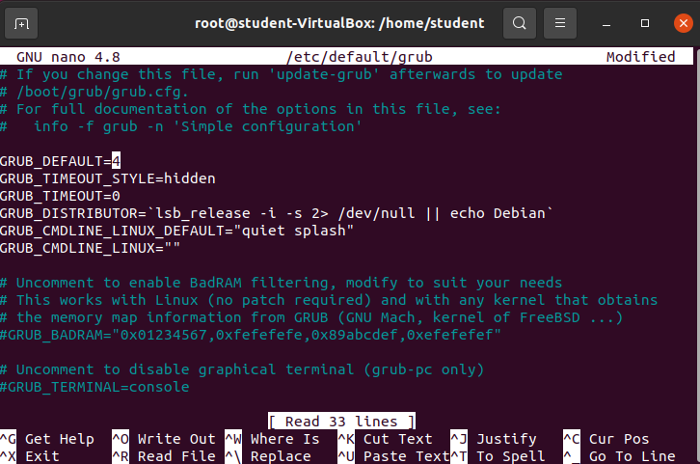

Then we have to confirm this change with the command *update-grub.*

*After that we have to comment the last lines in the screen showed below*



**3. If you lose the bootloader in exercise 2, use the tool “Boot-Repair”, which will let you solve the issue. If necessary, use the following the instructions in the URL:** [**https://help.ubuntu.com/community/Boot-Repair**](https://help.ubuntu.com/community/Boot-Repair)

**- At this point we have a problem, because we can´t open Ubuntu again, to solve this problema we need to put again the optical disk with Ubuntu and select try Ubuntu insted Install Ubuntu.**

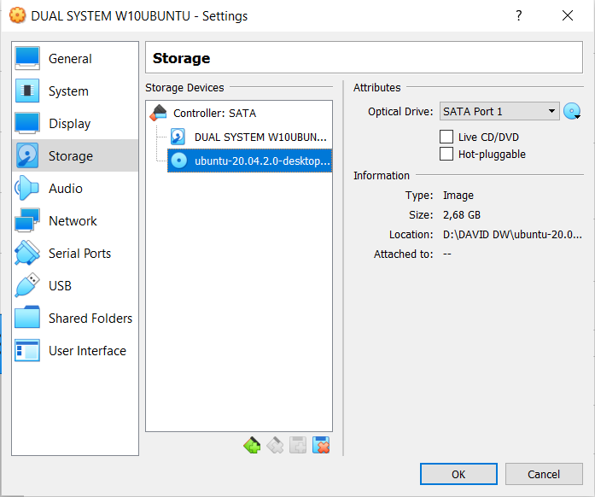

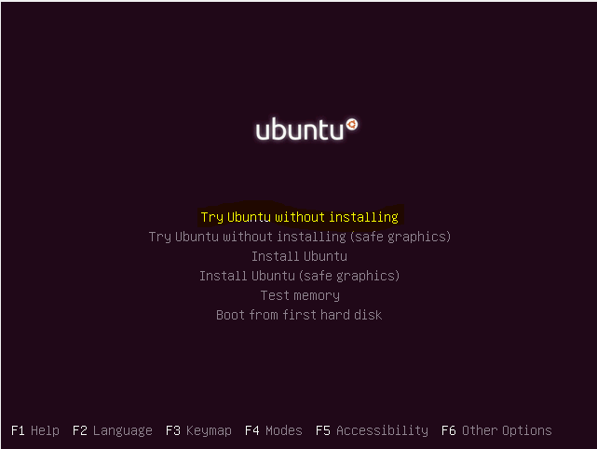

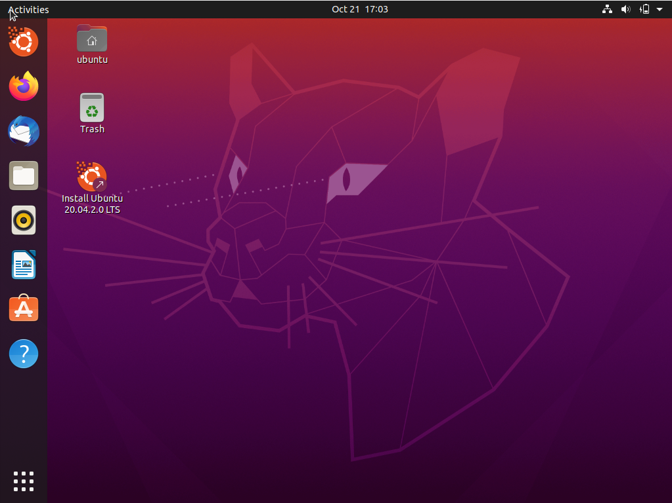

Ones we are in Ubuntu , open the terminal to repair the bootloader:

Then type the following commands, it´s necesary to press enter after each line.

sudo add-apt-repository ppa:yannubuntu/boot-repair

sudo apt-get update

sudo apt-get install -y boot-repair && boot-repair

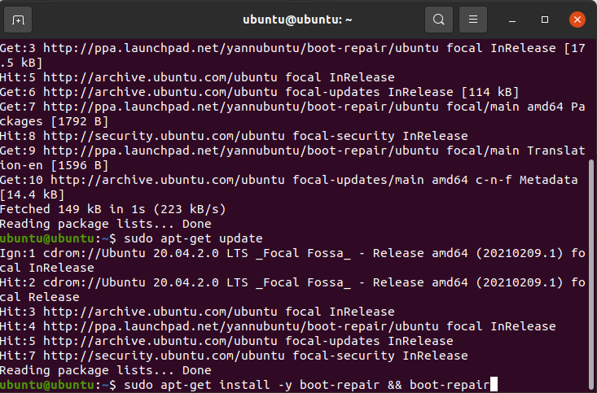

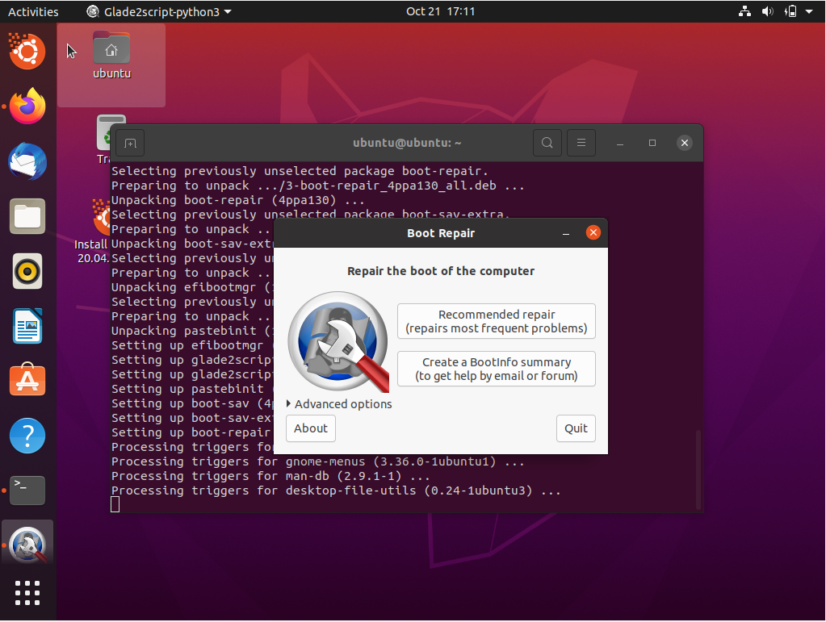

***Select recommended repair to finish.***

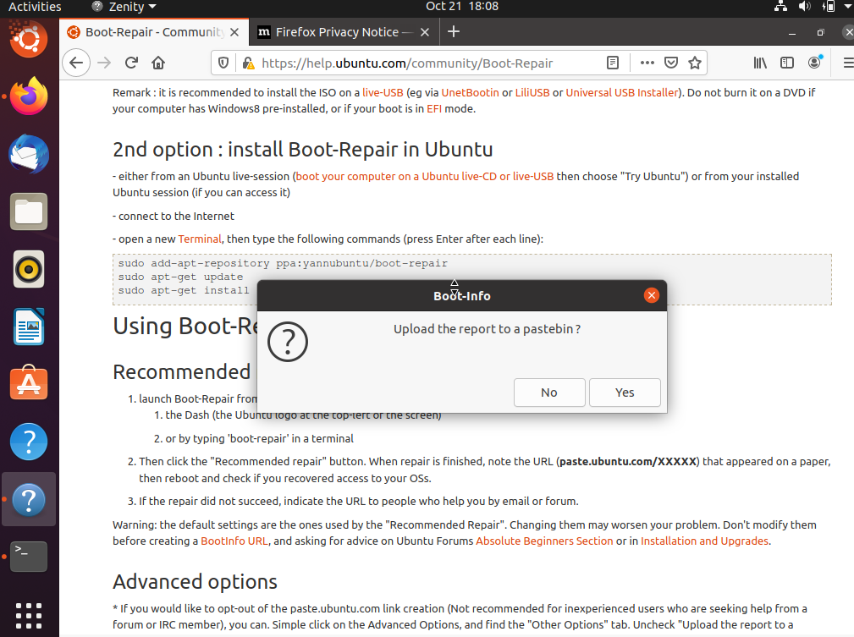

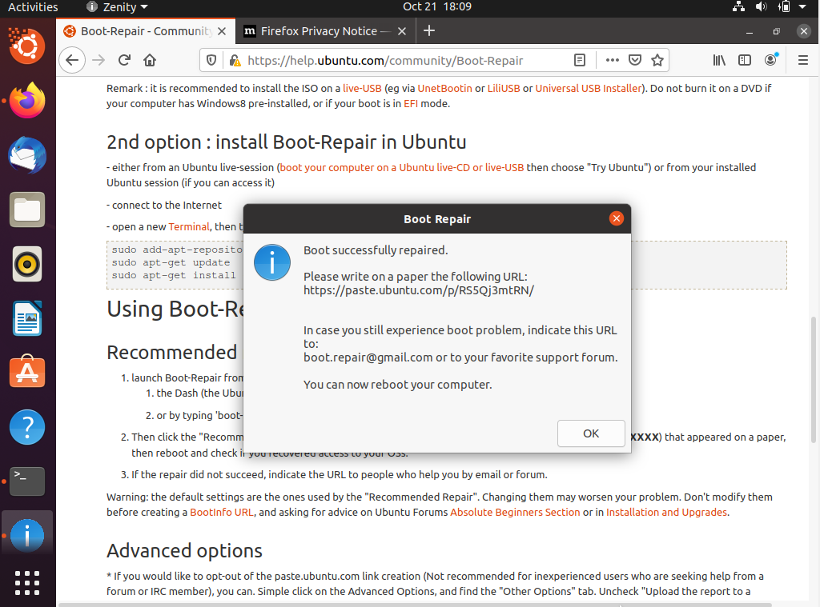

Finally we have the bootloader repaired as is showed in the screen below:

